
GAYAZA JUNIOR SCHOOL
LITERACY II FOR P.1 TERM I 2020

Name:________________________stream_______

- What is a school?
___________________________________
- Why do people go to school?
____________________________________
- Who heads a school?
____________________________________
- Give any two groups of people who work at school
__________________ _______________
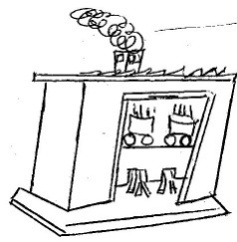
- Name these buildings found at school.
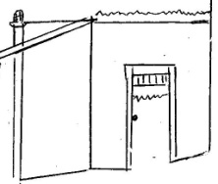

____________________________ ___________________________

- Where do school children go for treatment at school?_____________________________
- Why does a school need dormitories?
_____________________________________
- Fill in the missing letters.
te___cher st__nes nu__se
matr__n bu__sar penc__l
- What is the name of your headteacher?
______________________________________
10. Why is a teacher needed in a school?
______________________________________
11. Match people to their work places.
Cook classroom

Matron kitchen

Secretary office

Teacher dormitory
12. Name these classroom objects.
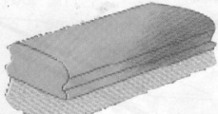 | 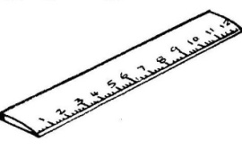 | 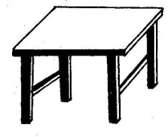 | 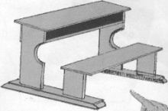

13. List down any three things found in the school
compound.
_________________ ________________
_________________
14. What is the use of brooms in our school?
_____________________________________
15. Where do we throw rubbish after picking it?
______________________________________
16. Where are school books kept?
______________________________________

17. Name these school symbols.


18. What is the colour of your school uniform?
______________________________________
19. What is your school motto?
______________________________________
20. Why do children wear school uniforms?
______________________________________
21. Write the three letters found on the school badge.
___________ ___________ ___________
22. Which school symbol directs people to school?
______________________________________

23. Name these activities done at school.
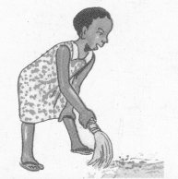 | 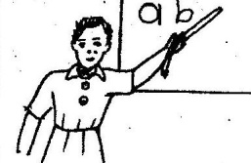 | 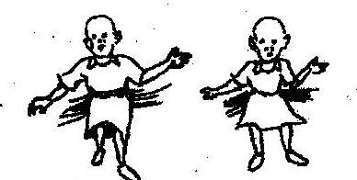

24. Name any two activities children do on sports day?
_______________________________
_______________________________
25. What is a home?
______________________________________
26. Who heads a family?
______________________________________
27. Why do we need a granary at home?
______________________________________
28. Where do people go for short or long calls at home?
______________________________________
29. Name these people found at home?
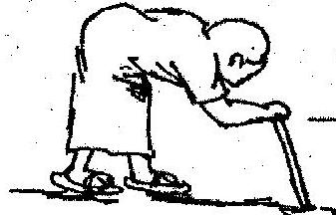 | 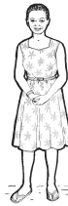 | 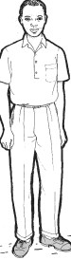

END

GJS LITERACY I P.1
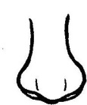
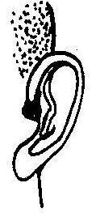
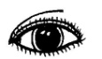
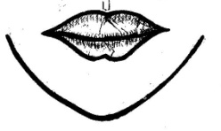
- Name these parts of the head.

2. Why do people need eyes?
______________________________________
3. Which body part do people use for smelling.
______________________________________
4. Write these words correctly.
i) thmuo ______________________
ii) sare ______________________
iii) cken ______________________

5. Name these things we use to clean our body?
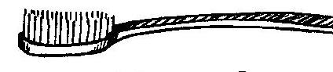
____________________
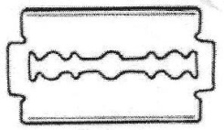
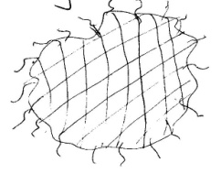
_____________________

_____________________
6. Why do people keep hens at home?
_____________________________________
7. How many legs has a cow?
___________________________________
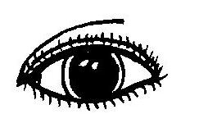
8. Match correctly.
Smelling
Tasting
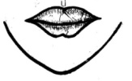
Seeing
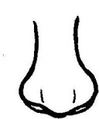
Hearing
9. Name the food we get from cows?
_______________________________________
- Write down any two animals which eat grass.
- __________________________
- _________________________
11. Fill in the missing letters.
i) w__t__r iv) sp__n__e
ii) bu__k__t
iii) s__ __p
12. Which animal eats rats at home?
___________________________________
13. Name these foods eaten at home.


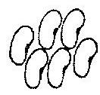 ________________ _________

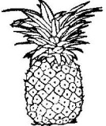 _______________ 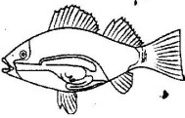 _________
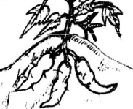
____________
14. Why do we brush our teeth?
______________________________________
15. Underline the common diseases.
Polio, Mumps, Tetanus, Whooping cough, Measles,
Malaria.
16. Name these activities we do to keep our bodies
clean.
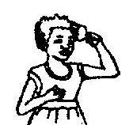
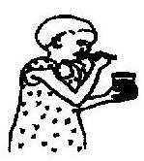

_______________ _____________

17. We__________our hands after visiting the toilets.

18. Which disease is spread by a mosquito.
__________________________
(Typhoid, Melarai, Malaria, Measles)

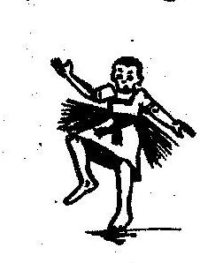
19. Name these body exercises.
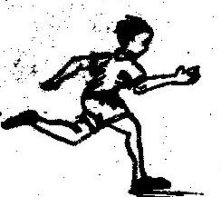
________________ __ _____________
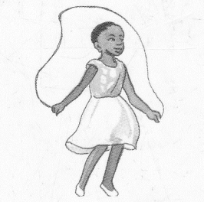

_______________

20. Name the parts of the arm.
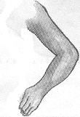

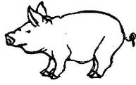
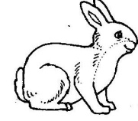
21. Name the animals.
______________ _____________
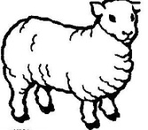
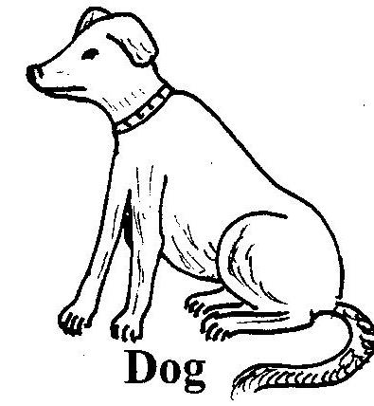
_____________ ____________
GJS MATHEMATICS P.1
1. Count and write

a) ______________________

b) _____________________


c) ______________________

d) ______________________

2. Name these groups.
a) A group of balls


b) ______________________________

c) ______________________________

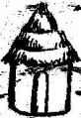
d) _________________________

3. Match the same groups.



4a) What is a set?
______________________________________
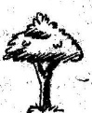

b) Match correctly.

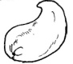
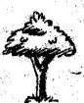
c) Match the same.

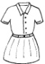
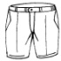
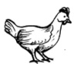
i)

5. Make new sets.

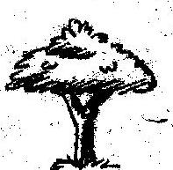
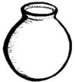
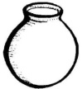

6. Draw the following sets.
a) A set of stars.

b) A set of flowers.

c) A set of pencils.

(d) A set of books

7. Identify numbers on the cards.
a)
___________
b) _____________

8. Comparing sets.
A B

a)
Set A has __________members.
Set B has __________ members.
b) M N

Set M has _____members.
Set N has _____members
9. Use less or more

a) A B

Set A has _________members than set B.
Set B has _________members than set A.
10a) What is an empty set?
______________________________________
b) Draw an empty set.

- Join the sets.

and make


b. and make

4 + ___ = ____
12. Separating sets.

a) _ =

b) _ =

- Fill in the missing ordinal numbers.
- 1st ____, 3rd _____, 5th

- 6th ____, 8th , 9th , ____

14. Ordering sets.

a) -2 -1 -3
Draw these sets again in order.


b)
-4 -3 -1 -2
The sets have been drawn again, order using ordinal numbers.

15. Fill in the missing numbers.
a) 1, 2, ___, 4, 5, ___
b) 7, 8, ___, 10, ___
c) 6, ___,4 , ___, 2, 1

16. Write number words.
8 __________________ 4 ______________
9 __________________ 3 ______________
7 __________________ 2 ______________
6 __________________ 1 ______________
5 __________________ 0 ______________
17. Add these objects.
a) + = _______

b) + = _______

18. Add correctly.
a) 4 + 3 = ____
b) 7 + 1 = ____
c) 2 + 0 = ____
d) 5 + 1 + 2 = ____
Add:
- 5 b) 6 c) 4
+3 + 2 1
+3

Add:
- Four plus three equals _____________
- Six plus one equals _____________
- What is five plus three?
- Anna has 4 books
Mary has +3 books
They both have books
19. Use taller, longer and shorter.
A
B

Bottle A is ________________than bottle B
Bottle B is ________________than bottle A

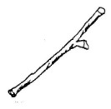
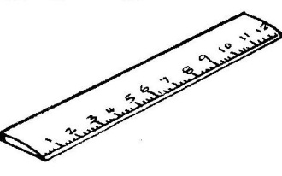
ruler
stick
- The ruler is ________________than the stick
- The stick is ________________than the ruler.
20. Use “heavier” or lighter”
a) stone A stone B

- Stone A is ______________than stone B.
- Stone B is ______________than stone A.
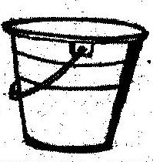
bucket
cup

- The bucket is _____________than the cup.
- The cup is _______________than the bucket.
Take away.
21. 9 -4 =
b) 5 - 5 =
c) 8
-3

d. Seven cats minus three cats

e. Eight dogs take away five dogs gives.

f. What is 7 minus 2?

Find the missing number.
- ______ + 5 = 8
- 6 + _____ = 10
END

GJS ENGLISH P.1
THEME : OUR SCHOOL
- My name is ____________________________
My school is ___________________________
My class is ____________________________
How old are you?
I am _____ years old.
Are you a girl ?
____________________________________
What is the name of your class teacher?
__________________________

- Fill in the missing letters of the alphabet.
- A B ___ D E F
- G___ I J K L
- M N O___ Q

- Write these words in small letters.
BADGE __________________
SCHOOL __________________
FLAG _____________________
Write these letters in ABC order.
- a f c b ______________
- k i l m ________________
Write the letter which comes before and after.
- ____ b ____ (b) ____ g ____
- Write ‘a’ or ‘an’ to complete the sentences correctly.

a) Show me ____ orange.
b) Bring me ___ hoe and ___ axe.
c) ______ aeroplane is flying over the hills

5. Read and draw people found at school.
Teacher | Pupil | Cook | Cleaner

6. Fill in He or She
i) Ritah is a girl
_____ is in Primary One.
ii) Peter is a boy
_____ is in Primary Two
- Our teacher of English is a woman.
______is called Mrs. Mwebaza.
- Our headteacher is a man
______ is called Mr. Musisi.

7. Name these objects.
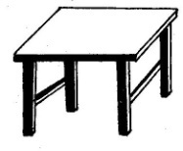
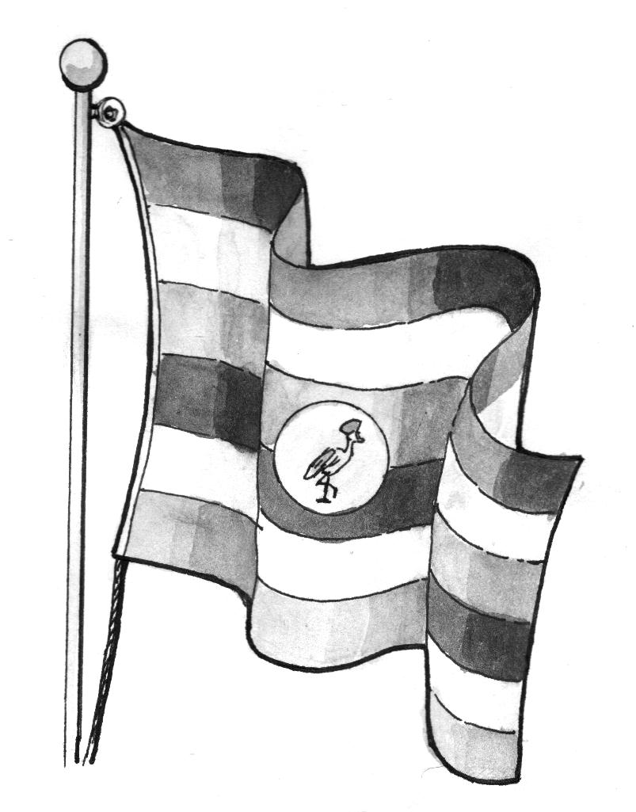

_________________ ____________
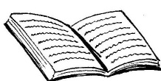
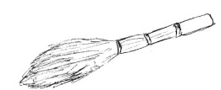
_______________ ____________

8. Fill in the missing letters.
w___nd___w p___nc___l d___st___r
r___ler cha___kbo__rd b___x
9. Activities done at school
Read and draw the picture.
Namuli is sweeping the compound.

John is reading a book.

Ritah is running to school.

Juma is dancing.

10. Complete the following sentences.

One ball many _________

One pencil many _________

One ______ many _________
11. Use the given words in their plural form.
a) Nalule has ten ______________(book)
b) These are two _____________(table)
c) There are twenty_________in the classroom. (girl)

12. Circle the oddman out.
a) chair tree, pencil, book.
b) Jane, Sarah, Peter, Ruth.
c) Chair, bag, knife, table.
d) goat, bench, duster, ruler.
Add -ing to the verb.
- clean = cleaning
- wash = _______________
- drink = _______________
- swim = _______________
- skip = ________________
- clap = ________________
- drive = ________________
- come = ________________
- weave = ________________

- Read and shade these colours.

blue yellow

green red

black purple

OUR HOME
- Fill in the gaps with ‘’is’’ or ‘’are’’
- There ____ many oranges in the basket.
- That _____ a policeman.
- These _____ yellow bananas.
- _______ Peter a good boy?
- Write these words correctly.
therfa _ __________ tersis _ _________
thermo _ __________ cleun _ _________
ons _ __________ manwo _ ________
sincou _ ________ mothergrand _ _________

- Write these sentences correctly.
- food cooking Mother is some
_________________________________
- pounding groundnuts. The grandmother is
_________________________________
- milking the cow Father is
_________________________________
- Draw and name four animals found at home.

- Use the words in brackets correctly.
i) The train is ___________on the railway line.
(move).
ii) The children are___________now. (dance)
iii) Mr. Kato is ___________in the garden.(dig)
iv) Alice is ______________ (grind)
v) Mrs. Kato is ___________ matooke. (peel)
20. Underline the doing word (verb)
1. I am learning English now.
2. The children are eating maize.
3. Mother is cooking maize.
4. The baby is sleeping.
5. The teacher is writing on the chalkboard.
21. Read and answer correctly.
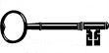
Is this a key?
Yes, it is


Is this a stone?
No, it is not.
Is this a hat?
____________________________
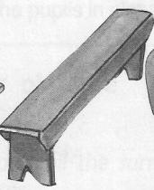
Is this a bench?
_____________________________
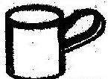
Is this a pot?
______________________________
Is this a tree?
_______________________________
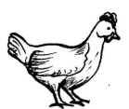
What are these?
_______________________________

How many eggs can you see?
_______________________________
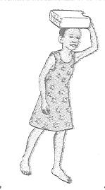
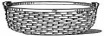
22. Make sentences about what is happening.
a)
_______________________________
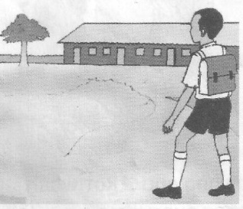
b)
_________________________


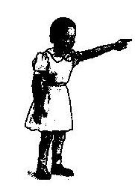
c)
_________________________________
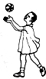
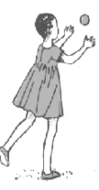
d) _______________________________
Read the story and answer correctly.
23. The Grandmother.
Nakato and Babirye have a grandmother. Her name is Mrs. Lubuto. She lives at Naalya town. She has a big farm. She grows maize, cassava, pineapples and sugarcane. She has goats, cows and sheep. She is a hardworking woman.
- What is the grandmother’s name?
The grandmother’s name is _______________
- Where does she live?
She lives at ___________________________
- What does she grow?
She grows maize, ___________and _________
- Write three animals she has
___________, ___________, __________
- Draw Nakato and Babirye with their grandmother.

END

